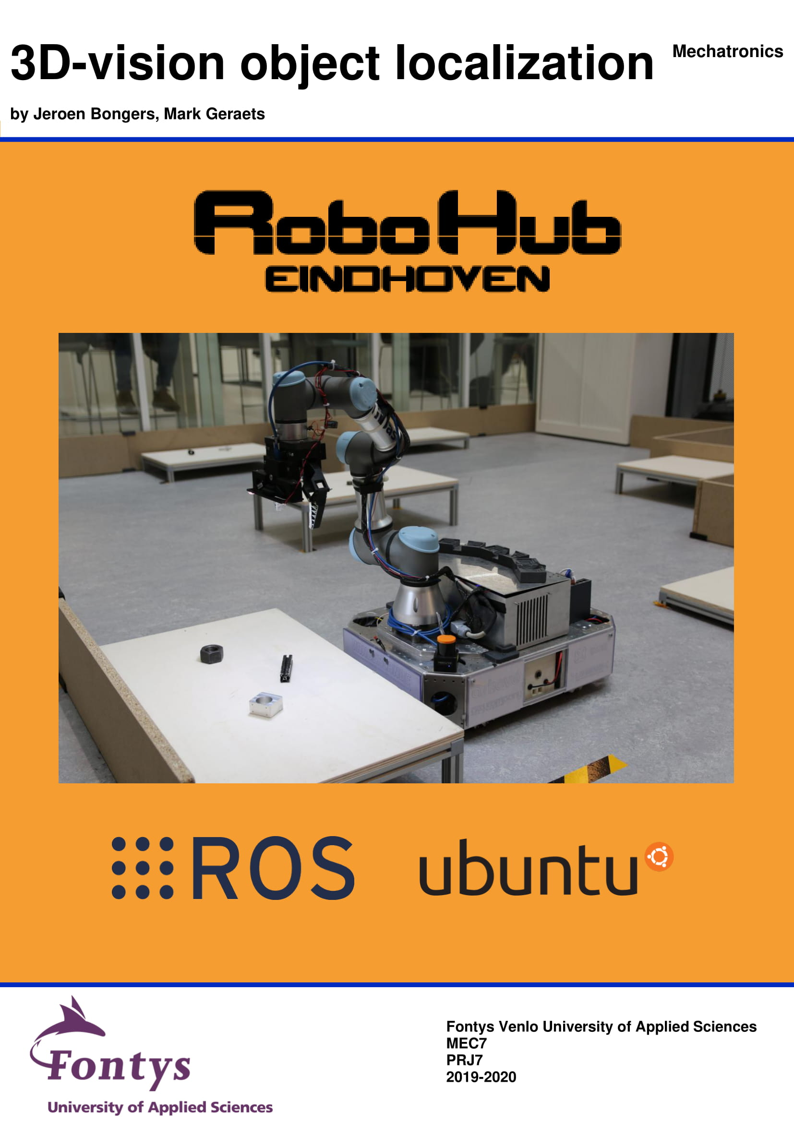

# Summary

RoboHub Eindhoven is a robotics team located in Fontys Eindhoven. RoboHub Eindhoven developed a robot which competes in the RoboCup@Work league. For this robot, RoboHub Eindhoven developed a 2D-vision system which can detect objects, and determine the orientation and rotation of the detected objects. The problem which RoboHub Eindhoven encountered was that the 2D-vision solution can’t measure depth, is ambient light depended and has problems locating shiny objects due to the light reflection from the objects.

To tackle this issue, a 3D-vision solution is requested. The goal is to create a 3D-vision application for the BlasterX Senz3D camera from Creative. This application must locate objects in 3D, meaning it needs to determine a transformation of an object and of the table underneath the object.

This request is answered by 4th years students from Fontys University of applied science, Venlo. In this project, a 3D-vision solution is created for RoboHub Eindhoven. The goal is to create a more accurate vision solution in comparison with the 2D-vision solution of RoboHub Eindhoven. The software needs to get the transformation of RoboCup@Work objects, with one object at a time, so object recognition is not mandatory for this project. The software is written in C++ and Python. ROS is used to communicate between the different languages and later on, with the robot. The 3D-vision solution can operate in a distance varying between 20 and 40 centimeters.

To create this software solution, research is done in 3D-vision. Pointcloud library is chosen to process the pointcloud data coming from the 3D-camera. The software will first get the camera data. Next, the data will be filtered by some algorithms followed by segmenting the data in different parts. This is done to separate the object from the table where the object is placed. After this, a transformation for the object and the table can be determined. Finally, the results are shown in a visualizer and printed to a terminal. All these steps are researched, programmed, tested and explained in this documentation. Next, a class and dataflow diagram are created to combine all the pieces of code to create a total solution of determining the transformation of objects. The total solution is programmed and tested.

Currently, object detection is integrated in the total 3D-vision solution. Unfortunately, it is not fully finished to operate with object detection. Locating one object at a time and locating the table, without object detection, is succeeded. The accuracy of the system is more accurate for all non-black objects. Due to the infrared working principle of the 3D-camera, black objects are still an issue since they absorb the infrared laser. As a recommendation, it is advised to finish the integration of object detection. Finishing this, will enable the functionality of detecting as many RoboCup@Work objects at a time as wished. Furthermore, a combination of 2D and 3D-vision is advised. Use 2D vision to determine de orientation and rotation of black objects and combine it with the depth measured from the table to also get the depth for picking an object. All other objects are advised to locate with 3D-vision since of the greater accuracy and precise depth of the object.

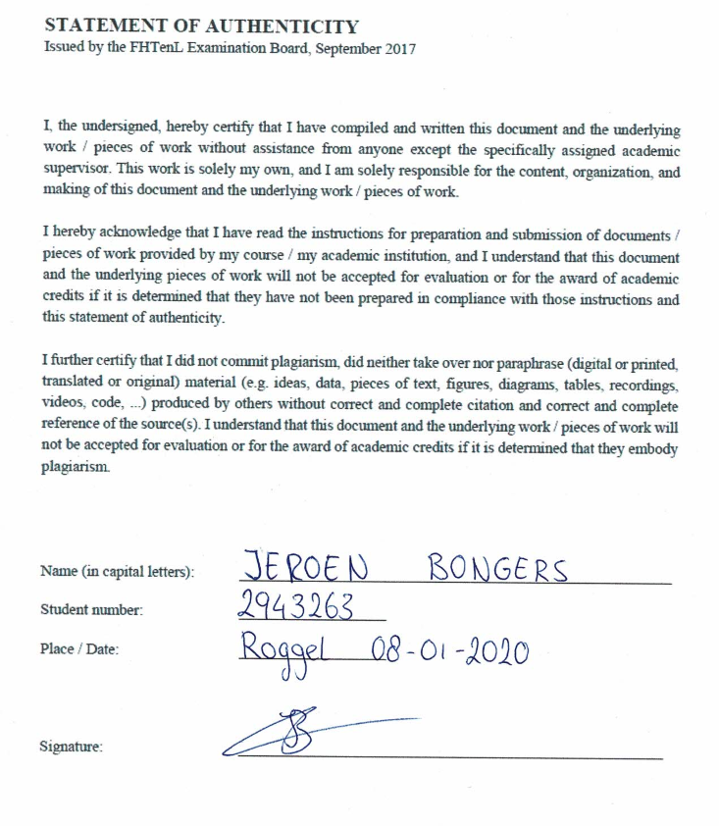

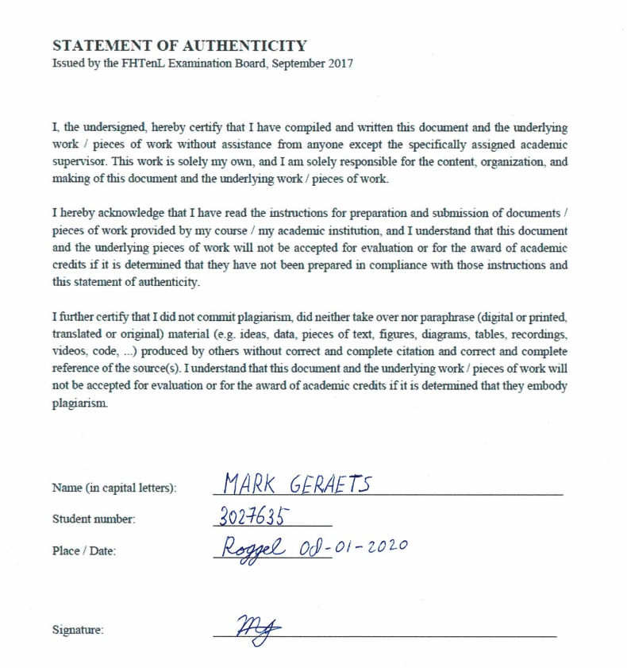

# Index

Summary 1

Index 4

1. Introduction 7

1.1 Goal and scope 7

1.2 Abbreviations 7

2. Requirements 8

2.1 Mandatory requirements 8

2.2 Variable requirements 8

2.3 Wishes 8

3. Basic design 9

3.1 Describing basic concept/ design 9

4. Research 10

4.1 Type of library 10

4.2 Table of options for basic design modules 11

4.3 C++ tutorials 11

4.4 Pipeline 12

4.4.1 Research pipeline 12

4.4.2 Testing of pipeline 12

4.4.3 Encountered Pipeline problems 13

4.5 Filtering 13

4.5.1 Research Filtering 13

4.5.2 Testing of Filtering 14

4.5.3 Encountered Filtering problems 15

4.6 Segmentation 16

4.6.1 Research Segmentation 16

4.6.2 Testing of Segmentation 17

4.6.3 Encountered Segmentation problems 17

4.7 TF 18

4.7.1 Research TF PCL 18

4.7.2 Testing of TF PCL 18

4.7.3 Encountered TF PCL problems 19

4.8 Visualizer 19

4.8.1 Research Visualizer 19

4.8.2 Testing of Visualizer 19

4.8.3 Encountered Visualizer problems 19

4.9 ROS 20

4.9.1 ROS research 20

4.9.2 Communication with YOLO 21

4.9.3 ROS services 21

4.9.4 TF broadcaster 22

5. Detailed design 24

5.1 Dataflow diagram 24

5.2 Class diagram 25

6. Software 27

6.1 Main 27

6.2 GetImages 27

6.3 Pipeline 27

6.4 Yolo_Wrapper 28

6.5 GetTf 28

6.6 Filter 28

6.7 Segmentation 29

6.8 Tf 29

6.9 Visualization 30

7. Measurement results/ testing 30

7.1 Test description 30

7.2 Accuracy X,Y,Z and Theta 31

7.2.1 Axis 31

7.2.2 Bearing 32

7.2.3 Bearing box 33

7.2.4 Big black profile 34

7.2.5 Big nut 35

7.2.6 Distance tube 36

7.2.7 Motor 36

7.2.8 R20 38

7.2.9 Small aluminum profile 39

7.2.10 Small black profile 40

7.2.11 Small nut 41

8. Final status 42

9. Conclusions 44

List of tables 45

List of figures 46

Reference list 48

Appendix 49

Appendix A: RoboCup@Work objects 49

Appendix B: Theta explanation 50

Appendix C: Asymmetric objects 51

Appendix D: Test Plan 52

Appendix E: List of tutorials 57

Appendix F: Task division 58

# Introduction

## 1.1 Goal and scope

RoboHub Eindhoven is a team of motivated students and professionals that are working together to discover new solutions for robotic systems. RoboHub Eindhoven is located at Fontys Eindhoven where they have the space to develop their systems and robots. RoboHub Eindhoven annually takes part in the RoboCup@Work competition. This international competition focuses on industrial automation. All teams in the RoboCup@Work league compete with an AGV with and a robotic arm on it. These robots must perform autonomous tasks such as navigating through a dynamic environment, picking and placing objects and transporting them. The current robot that is used by RoboHub Eindhoven is called Suii. Suii currently only uses 2D vision to recognize objects and determine how to pick or place them. 2D vision is light depended and has problems determining the transformation of shiny objects because of the light that gets reflected. RoboHub Eindhoven wants to solve those problems by using 3D vision instead or in combination with 2D vision to get a better, more accurate and more robust system.

The goal of this project is creating a 3D solution that determines the orientation and rotation of a RoboCup@Work object and that broadcasts the transformations of those objects via ROS.

## 1.2 Abbreviations

|  |  |
| --- | --- |
| C++ | C plus plus |
| m | Meter |
| mm | Millimeter |
| PC | Point cloud |
| PCD | Point cloud data |
| RGB | Red Green Blue |
| ROI | Region of Interest |
| RS | RealSense |
| SDK | Software Development Kit |
| TF | Transformation |
| YOLO | You Only Look Once |

Table : Abbreviations

# Requirements

The requirements of this project are defined at the beginning of the project. You can find the requirements and wishes in the upcoming paragraphs.

## 2.1 Mandatory requirements

1. The camera that needs to be used is the BlasterX Senz3D from Creative
2. It must be possible to broadcast a TF of every RoboCup@Work object, listed in Appendix A: RoboCup@Work objects
3. Only one RoboCup@Work object at a time, will be present on a table per scan to test our system
4. The software needs to be written in C++ or Python
5. The system needs to work on a scan height between 20 and 40 cm’s. Parallel to the table surface
6. The software must be modular so that it can be used for multiple purposes
7. Software is published on the GitHub of RoboHub Eindhoven and a wiki is written for it

## Variable requirements

1. The 3D system needs to be more accurate than the 2D system that is made last year by RoboHub Eindhoven
2. There needs to be a function for getting the table height

## Wishes

1. Researching object detection for 3D vision

# Basic design

## 3.1 Describing basic concept/ design

To calculate a transformation of objects in a point cloud, there are few steps required to process, shown in Figure 1.

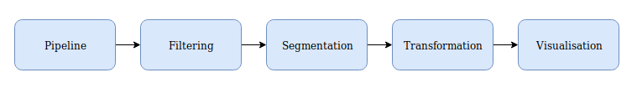

Figure : Basic design

First, a point cloud and an RGB image are required from the camera. This is done through a pipeline. The next step will be filtering the images where necessary. After this the PC needs to be divided in a table PC and different object PC‘s. This is done in the segmentation step. Finally, the TF of every segmented PC can be calculated. This is done in the transformation step. For user interfacing, the results are visualized in the visualization step.

# Research

## 4.1 Type of library

Before starting with programming, a library for processing and visualizing the PC had to be chosen. The options that were found are listed in Table 2.

|  |  |  |
| --- | --- | --- |
| **Name** | **Pro’ s** | **Con’ s** |
| Point Cloud Library (PCL) | * Very Good documentation * Lot’ s of examples * Very extensive * ROS interface | * Only fully supports C++ (incomplete wrapper for Python) |
| Open3D | * Good documentation * Supports Python and C++ | * No ROS interface |
| 3DTK |  | * No ROS interface * Only supports C++ * Little documentation * Few examples |
| PDAL | * Supports Python and C++ * Lot’ s of filters | * No ROS interface * Little documentation |

Table : Library research

PCL was chosen because of the amount and quality of documentation it had and because there where so many examples, and diverse possibilities. Also did it feature a ROS interface which is needed in the project. PCL only fully supports C++ that’s why C++ tutorials were used to learn C++. More info about C++ will be given in paragraph 4.3 C++ tutorials.

## 

## 4.2 Table of options for basic design modules

From the chosen library, we started to research all the different options/ solutions per step needed to get a TF from an object. All these options are listed in the table Table 3.

|  |  |  |  |  |
| --- | --- | --- | --- | --- |
| **Pipeline** | **Filtering** | **Segmentation** | **Transformation** | **Visualisation** |
| RealSense library | Passthrough filter | Plane model segmentation | Moment of inertia | The CloudViewer |
|  | Voxel grid filter | Cilinder model segmentation | GASD | PCLVisualizer |
|  | Radius outlier removal | Euclidean cluster extraction |  |  |
|  | Conditional removal | Region growing segmentation |  |  |
|  | Statistical outlier removal | Color-based region growing segmentation |  |  |
|  |  | Min-cut based segmentation |  |  |
|  |  | Conditional Euclidean clustering |  |  |
|  |  | Difference of normals based segmentation |  |  |

Table : Basic design

The next thing to do is to work out every step. For each step, there is one or more option/ solution chosen. The chosen solutions are programmed to test if the solution works as expected. These steps are explained from paragraph 4.4 Pipeline until paragraph 4.8 Visualizer. All the used tutorials are listed in Appendix E: List of tutorials.

## 4.3 C++ tutorials

As described in paragraph 4.1 Type of library, the language required to use PCL library is C++. C++ is a general-purpose programming language and is an extension of the programming language C, also called C with classes. For this, the first step is to learn C++ by following tutorials. C++ is programmed in the integrated development environment Visual Studio Code because we were already experienced with Visual Studio Code. Since a lot of libraries needed to be include in this project, we chose to use CMake for building our C++ codes. With CMake you are able to create your own CMakeLists which is needed to build your projects and include libraries. CMakeLists makes it easier to include libraries such as the PCL library. Using C++ results in succeeding requirement 4: The software needs to be written in C++ or Python.

(Wikipedia 2019a)

(Visual Studio code 2019)

(Cmake 2019)

## 4.4 Pipeline

### 4.4.1 Research pipeline

The goal of the pipeline will be getting an RGB and depth image. This RGB image will be used with YOLO to find the objects. YOLO is a real time object detection system. It makes use of a neural network that is pretrained to detect different objects (YOLO 2018). The YOLO code that is used is made by RoboHub Eindhoven. Since this is already made by RoboHub Eindhoven it is reused to save time. To combine it with 3D vision the ROI that is returned by the YOLO network needs to be cut out of the PC. The depth image will be used to generate a PC. This PC will be further used in our code to find the location and angle of the object. The camera that is used is the BlasterX Senz3D from Creative. This camera is built up from an Intel RealSense SR300 (Creative 2019). The Intel Realsense SR300 uses coded light to create a depth image of the scene. It projects a known grid of infrared points onto the environment and measures the changes in this grid. With these measurements and the known grid, it calculates a depth image of the environment it sees. Because of the RealSense inside there has been chosen for using the Intel RealSense SDK 2.0. This is a library made for the Intel RealSense series. This is a series of camera’s made by Intel. The RealSense SDK has support for the SR300 and contains a lot of documentation. This made it relatively easy to set up the pipeline (Intel 2018).

### 4.4.2 Testing of pipeline

To test the pipeline, there is searched on the internet for examples and a little test is made. The test successfully gets an RGB and depth image and converts this depth image into a PC. Figure 2 shows the output of the pipeline test. The left image shows the RGB image that is made, and the right image shows the corresponding PC. The PC has an offset relative to the RGB image because the PC is created with another camera within the BlasterX Senz3D.

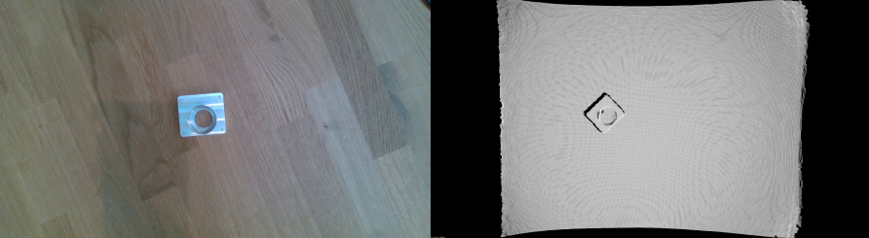

Figure : Pipeline test

To test YOLO, the code from last year is used. The test successfully finds the objects and draws a ROI rectangle around them. Figure 3 shows the output of the YOLO network. It draws a rectangle around the objects that it finds and prints the name and probability that it found the right object.

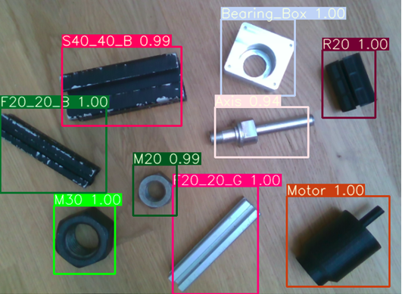

Figure : YOLO output

### 4.4.3 Encountered Pipeline problems

Current newest Intel RealSense SDK 2.0 version is 2.30. There have been some encountered problems with this version, it had problems with setting up the pipeline and grabbing frames from the RealSense SR300. Because of these problems there is chosen to switch to 2.29 and build it from source. No problems were encountered afterwards.

It appeared that the Creative BlasterX Senz3D has trouble seeing black objects, so there has been a quick test with the Intel RealSense D435. This camera uses two RGB cameras to generate a depth image. To check whether the D435 was a good alternative for our problem, the depth image was checked in the RealSense viewer. The two depth images from the two cameras are shown in Figure 4. The left image is from the D435 and the right image is made with the SR300. In the right image, the parts that are black have no depth data. These were all the black objects on the table. It is clearly visible that the left image can see the black objects but has more noise in the image itself. When the image from the D435 was checked from the side it was visible that the table surface was not smooth at all. The depth image that was made with the SR300 did not have so much noise and had a smooth table surface. Our findings were discussed with the client and there has been chosen for continuing with the SR300. To find the black objects, 2D vision needs to be used.

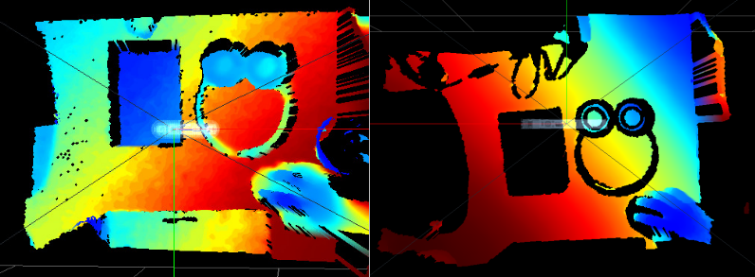

Figure : Camera issue

## 4.5 Filtering

### 4.5.1 Research Filtering

The goal of filtering will be improving the quality of the PC’ s, improve processing time and getting the PC points that are in the ROI that comes out of the YOLO network. In Table 4 the filter options that are found are listed. For every option there is looked for pros and cons compared to the goal.

|  |  |  |
| --- | --- | --- |
| **Option** | **Pros** | **Cons** |
| Passthrough filter | Removes points outside a predefined window |  |
| Voxel grid filter | Reduces points for faster processing times |  |
| Radius outlier removal |  | Removes point out of a circle |
| Conditional removal | Removes points that are outside the conditions that are defined. |  |
| Statistical outlier removal | Can remove noise and inaccuracies in the PC |  |

Table : Filter research

The Passthrough, Voxel grid filter and the statistical outlier removal are chosen for reducing the number of points, the statistical outlier removal for removing the noise and inaccuracies out of the PC. Conditional removal is not used because it is very similar to the passthrough filter and does not add extra value. If there are new problems faced concerning filtering, there can be chosen to switch to other filters that are found.

### 4.5.2 Testing of Filtering

To test the Passthrough filter, Voxel grid filter and Statistical outlier removal we followed tutorials on the from PCL library.

Passthrough filter tutorial: (Pointcloud 2019f).

In this tutorial only points on the z axis are filtered out. The code has been changed to cut out a rectangle from the PC. A Box Filter is used to realize this.

Voxel grid filter tutorial: (Pointcloud 2019g).

Statistical outlier removal tutorial: (Pointcloud 2019h).

All filters are tested with the same input PC. The passthrough filter successfully cuts out a rectangle out of the PC. The Voxel grid filter successfully decreased the amount of points and changed the size of the PC. The Statistical outlier removal filter successfully removed outliers out of the PC and that way reduces the amount of noise in the PC. As a conclusion, we proceed working with these three filters and not search for more or new filters. If we encounter specific problems, we can choose to do more research in filters.

**Results:**

Figure 5 shows the PCD that is used as input for the passthrough and voxel grid filter. Figure 6 shows the PCD after passing the passthrough filter. Note that the curled-up edges are filtered away and the size of the PC is reduced. Figure 7 shows the PCD after passing the voxel grid filter. The voxel grid reduced the amount of points in the PC.

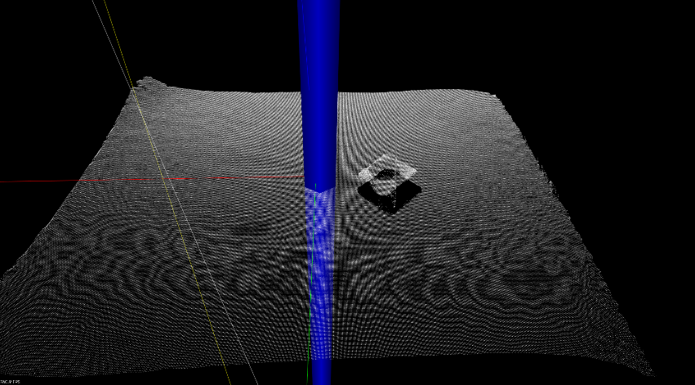

Figure : Passthrough and Voxel grid filter input

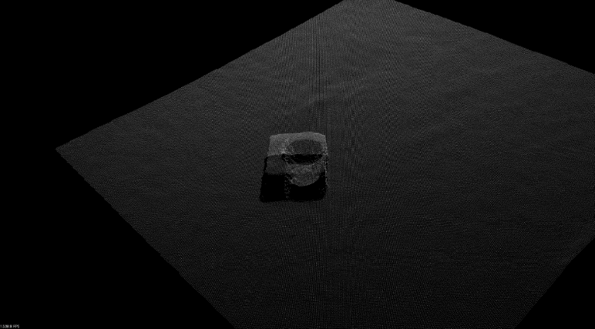

Figure : Passthrough filter output

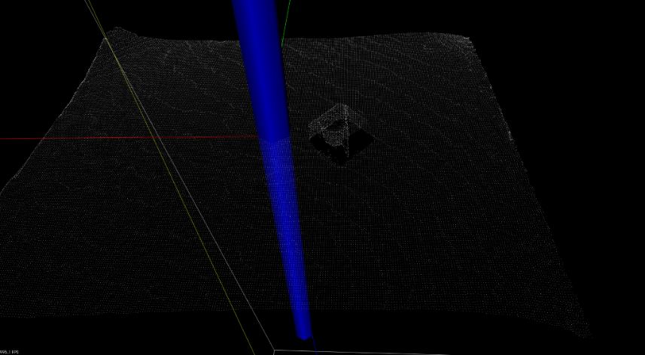

Figure : Voxel grid filter output

### 4.5.3 Encountered Filtering problems

There are no problems encountered during the filter tests.

## 4.6 Segmentation

### 4.6.1 Research Segmentation

The goal of segmentation will be detecting the table and objects and separate them as different PC’s. From these separated PC’s a TF can be calculated described in paragraph 4.7 TF. The first step will be taken with PC’s containing only one object at a time, as described in the requirements and go on from that point to more objects at a time in one PC. In Table 5 all the different options in segmentation are listed. For every option the pros and cons are compared to our goal.

|  |  |  |
| --- | --- | --- |
| **Option** | **Pros** | **Cons** |
| Plane model segmentation | Can detect planes in a PC, meaning I can de detect a table and separate it out. |  |
| Cylinder model segmentation |  | Can only detect cylindrical objects. |
| Euclidean cluster extraction | This will cluster all different shaped objects and create different PCD’s per object/cluster. |  |
| Region growing segmentation |  | Can cluster surfaces, meaning it will cluster a cube in more clusters/ surfaces |
| Color-based region growing segmentation |  | Can cluster objects based on color, meaning we are color and light depended (which we didn’t want since we are upgrading from the 2D solution). |
| Min-cut based segmentation |  | This segmentation solution needs an pregiven center of the object for it can segment. |
| Conditional Euclidean clustering | This is a combination of Euclidean cluster extraction and Color-based region growing segmentation and needs a lot of self-finetuning | More complex to use and integrated in comparison with Euclidean cluster extraction alone. A lot of manual fine tuning is required. |
| Difference of normals based segmentation |  | This option won’t output or cluster PCD’s but return normals as outputs. Normals are vectors perpendicular to the tangent plane of the surface at certain point (Wikipedia 2019c). |

Table : Segmentation research

To working methods will be the plane model segmentation and Euclidean cluster extraction. With the plane model segmentation, the table can be separated from the object. Euclidean cluster extraction is chosen for clustering the objects and returning a PCD for every object found. This is useful when we later want to use our software when there is more than one object on the table. Conditional Euclidean clustering is an option for later, due to its complexity. The first step is to start with Euclidean cluster extractions and make a working concept with it and test it.

### 4.6.2 Testing of Segmentation

To test the plane model segmentation and Euclidean cluster extraction the example tutorials from the PCL library are used with custom made images from one object on a table.

Plane model segmentation tutorial: (Pointcloud 2019a)

Euclidean cluster extraction tutorial: (Pointcloud 2019b)

We tested both segmentations with the same input PC. The plane model segmentation successfully extracted the table as the plane. The Euclidean cluster extraction successfully extracted the object from the table. The results are shown in Figure 8 and Figure 9. Due to the succeeded tests, the choice is made not to test the conditional Euclidean clustering to save time and proceed working on a total solution of the software.

***Results:***

Figure 9 shows the successfully segmented object. Figure 8 shows the successfully segmented table.

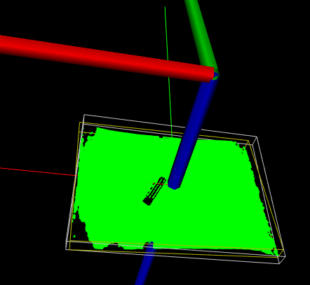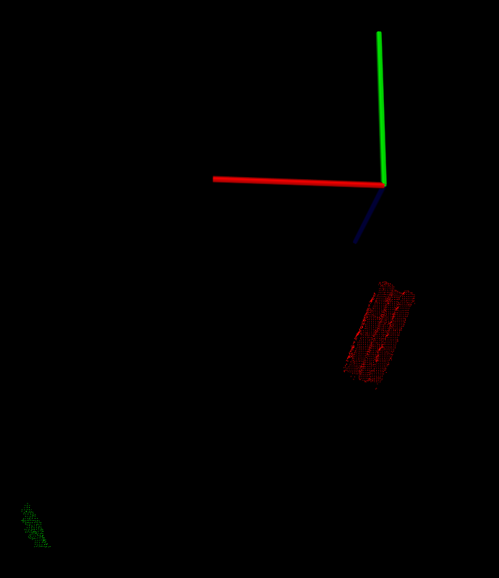

Figure 8: Table segmentation

Figure 9: Object segmentation

### 4.6.3 Encountered Segmentation problems

There are no problems encountered during the segmentation tests.

## 4.7 TF

### 4.7.1 Research TF PCL

For determining a transformation from an PC, the choice is made to use the moment of inertia class to calculate a TF of a PC. The GASD class is not used since it also uses object recognition. If GASD would be used, a colored PC needed to be made from every object. GASD will compare the known object PC with a new taken PC, and checks if it can find a similar PC and determine the TF from it. The moment of inertia class is much easier to use. It only takes a PCD as an input and calculate the TF with a library from PCL. With the use of the moment of inertia class, the software solution will be more modular. With the moment of inertia class an unknown/ untrained object can be used to determine a TF of the given PC. The outcomes of this class are four datapoints which contain a x, y and z value. One for the center point and one for each endpoint in the x, y and z direction. These datapoints can directly be used in the PCL visualizer described in paragraph 4.8 Visualizer. For more information about the moment of inertia class, please check the PCL tutorial.

(Poincloud 2019c)

(Pointcloud 2019d)

### 4.7.2 Testing of TF PCL

For testing the moment of inertia class, the tutorial moment of inertia tutorial of PCL is used. (Pointcloud 2019c). The test is succeeded with a given PC from the PCL library. Below in Figure 10 the test result is shown. Testing the accuracy of this solution will later be done in the final tests in chapter 7.2 Accuracy X,Y,Z and Theta. In these tests, all the different pieces of code are combined and can determine the TF of given objects.

***Result:***

Figure 10 shows the successful result of the TF determination by moments of Inertia:

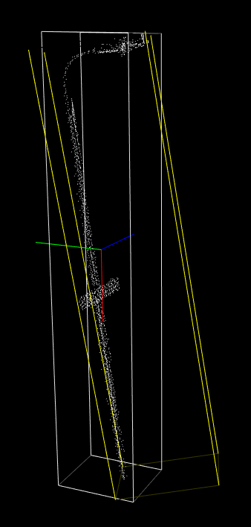

Figure : TF moment of inertia

(Pointcloud 2019c)

### 4.7.3 Encountered TF PCL problems

There are no problems encountered during the transformation tests.

## 4.8 Visualizer

### 4.8.1 Research Visualizer

For visualizing a PC, PCL's CloudViewer or PCLVisualizer could be used. For visualizing a PC clearly, it is mandatory to color every object in different colors in a PC. Also, the TF’s of every object and of the camera need to be visible in the visualiser. Since CloudViewer is only able to simply show a PC and you can’t modify its color and add TF’s, PCLVisualizer will be used which is able to perform the required tasks.

### 4.8.2 Testing of Visualizer

For testing the PCLVisualizer, the PCLVisualizer tutorial is followed. (Pointcloud 2019e)

The PCLVisualizer is successfully tested.

***Result:***

Figure 11 shows the result of the PCLVisualizer:

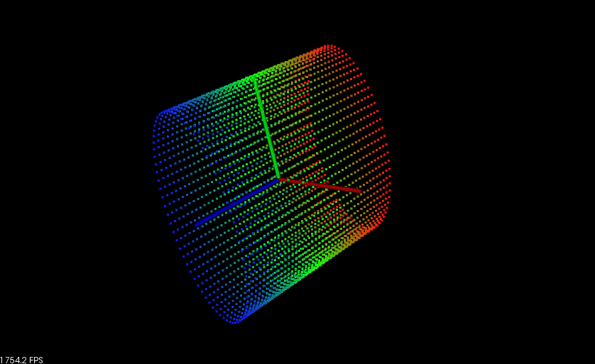

Figure : PCLVisualizer

(Pointcloud 2019e)

### 4.8.3 Encountered Visualizer problems

There are no problems encountered during the visualizer tests.

## 4.9 ROS

### 4.9.1 ROS research

ROS stands for Robot Operating System and is a framework for writing robot software. It is a collection of tools, libraries and conventions that aims to simplify the task of creating complex and robust robot behavior across a wide variety of robotic platforms (ROS 2019a). The ROS version that is used is ROS1.

ROS1 Packages contain:

- Own folder

- CmakeLists.txt which uses catkin

- Catkin compliant package.yml

ROS Nodes:

- Executable that uses ROS to communicate with other nodes

- Can publish or subscribe to a topic

- Can provide or use a service

ROS Topics:

Nodes communicate with each other over a ROS Topic. A node publishes data on a topic where other nodes can subscribe to this topic to receive the data that gets published.

ROS Message:

Messages are used to communicate between nodes. For the publisher and subscriber to communicate they must send and receive the same type of messages. The topic type is defined by the message type published on it.

ROS Services:

Nodes can communicate with each other via services. Services allow nodes to send a request and receive a response.

MSG and SRV:

- msg files are simple text files that describe the fields of a ROS message. They are used to generate source code for messages in different languages. Msgs are simple text files with a field type and field name per line. The filed types that can be used are:

* int8, int16, int32, int64 (plus uint*)
* float32, float64
* string
* time, duration
* other msg files
* variable-length array[] and fixed-length array[]

- srv files describe services. It is composed of two parts: a request and a response

- msg files are stored in msg directory and srv files are stored in srv directory

(ROS 2019b)

### 4.9.2 Communication with YOLO

The YOLO code is reused code that is made by members of RoboHub Eindhoven. This is programmed in Python 3 so there needed to be some form of communication between the PCL code and the YOLO part. At first it looked like this could be done directly through ROS, but ROS only supports Python 2 and so cannot be used with our Python 3 code. To tackle this problem there is another way of communication needed between ROS and Python 3. Last year Marian Lepădatu (Co-Founder of RoboHub Eindhoven) made this communication and he helped us integrate it into our own system. With his code we managed to send the RGB image from the YOLO_server code to the YOLO_main code and retrieve ROI back. The YOLO_server gets the image data from a C++ code via ROS and sends it via the image transfer protocol (Made by Marian) to the YOLO_main. The YOLO_main receives the image data and calls the YOLO function. YOLO returns the ROI’s and this data gets send back to the YOLO_server and after that returned via ROS to a C++ code. Figure 12 shows a diagram of the communication system that is used.

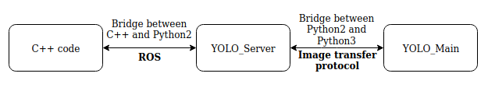

Figure : Communication YOLO

The communication layer between C++ code and YOLO_Server is explained in paragraph 4.9.3 ROS services.

### 4.9.3 ROS services

As described in paragraph 4.9.2 Communication with YOLO a communication layer was required to send a ROS image message from a C++ code to a python2 code. The use of ROS services is chosen. This is chosen because you can create a server, which only responds on a request of a client connected to the server. Due to this, the software doesn’t need to publish data constantly, and only sends data once when requested. For the upcoming explanation, Figure 13 is used.

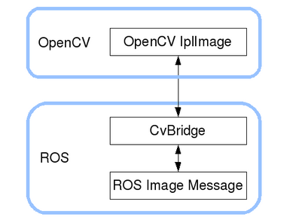

Figure : CvBridge

(ROS 2019c)

For sending an image through ROS services, a ROS sensor_msgs/Image is required. The camera gets a cv::Mat image from the Pipeline, which needs to be converted to the ROS sensor_msgs/Image. This is done by using the CvBridge package. This is a package contains a protocol to transform the cv::Mat datatype to the sensor_msgs/Image datatype. For more information about CvBridge please check out the ROS website (ROS 2019c). For information and tutorials about ROS services check out (ROS 2019d).

### 4.9.4 TF broadcaster

#### 4.9.4.1 Research TF broadcaster ROS

For publishing the TF's in ROS, the TF package of ROS is used which enables you to keep track of 3D coordinate frames. The TF broadcaster is required for the end system Suii, described in chapter 1. Introduction. This system currently operates with TF broadcasters throughout the hole system shown in Figure 14. This way it knows the precise transformation of every part of the system. Due to the TF’s, the robotic system can calculate how to grab an object and where to grab it.

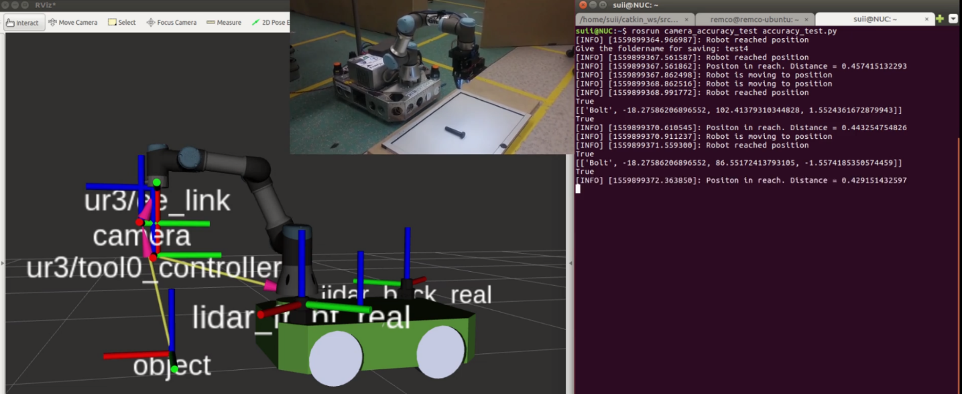

Figure : TF broadcaster

To learn how to use TF broadcaster a ROS tutorial is used, writing a TF broadcaster in C++ (ROS 2019b). To publish a TF with TF broadcaster we need the orientation and rotation of the object. The orientation are measurements in meters in the x, y and z direction. For the rotation quaternions are used. The outcome from the TF class moment of inertia is described in 4.7.2 Testing of TF PCL. These results are only the starting coordinates of the center and the end points in the x, y and z direction. These coordinates of the center could directly be implemented in the orientation values of the TF Broadcaster. The rotation is calculated as the jaw relative to the x-axis. Only the jaw is calculated because the camera looks parallel to the table, so the only rotation that is seen is the jaw. The rotation is calculated as show in Figure 15. The arrows point out in which directions the axes are positive. The x, y plane is divided into four regions. Every region has its own formula to calculate the rotation relative to the x-axis, these are at the arrows. All angles that are used in the formulas are absolute values.

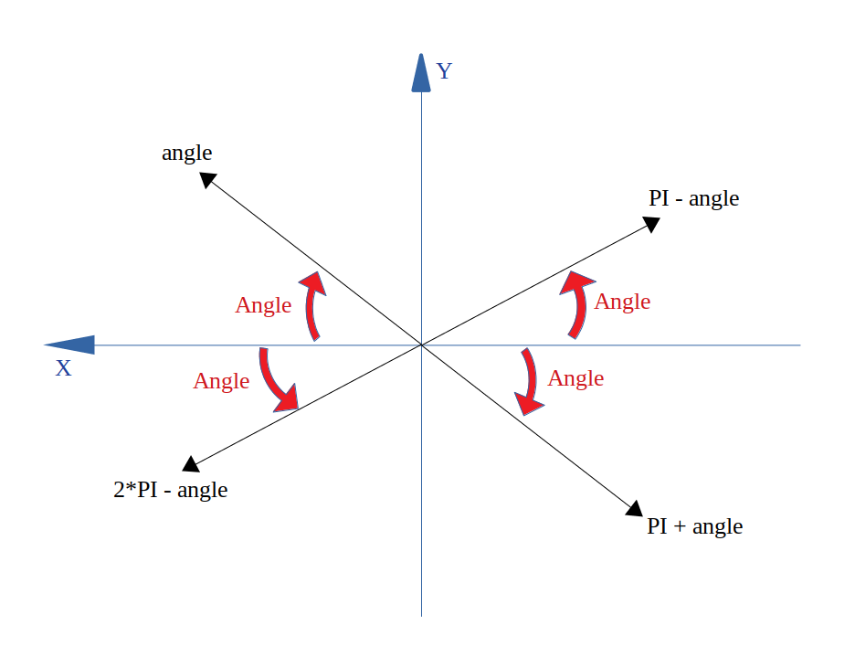

Figure : Euler

After the results of the jaw we converted the value from Euler to quaternions using conversion calculations found on (Wikipedia 2019b).

#### 4.9.4.2 Testing of TF broadcaster ROS

To test the if the TF broadcaster works, Rviz is used to receive the broadcasted TF’s. Rviz stands for ROS Visualization. Rviz is a 3-dimensional visualization tool and it enables you to visualize what a robotic system is doing and seeing. The results from the TF moments of inertia class are printed to the terminal and compared to the values Rviz received. Rviz successfully received the TF’s. The results are shown below in

Rviz (2019)

***Results:***

Figure 17 shows the results from the code. Figure 16 shows the same result but then received in Rviz.

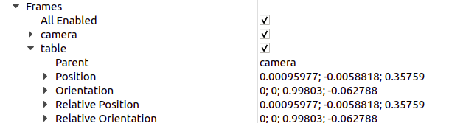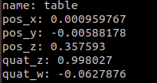

Figure 16: TF values from Rviz

Figure 17: TF values from code

#### 4.9.4.3 Encountered TF broadcaster problems

There are no problems encountered during the segmentation tests.

# Detailed design

The software design is shown in a dataflow diagram and a class diagram. Since the class diagram is too big to show in one image, the classes are shown as separate classes in 5.2 Class diagram. The dataflow diagram is shown in paragraph 5.1 Dataflow diagram.

## 5.1 Dataflow diagram

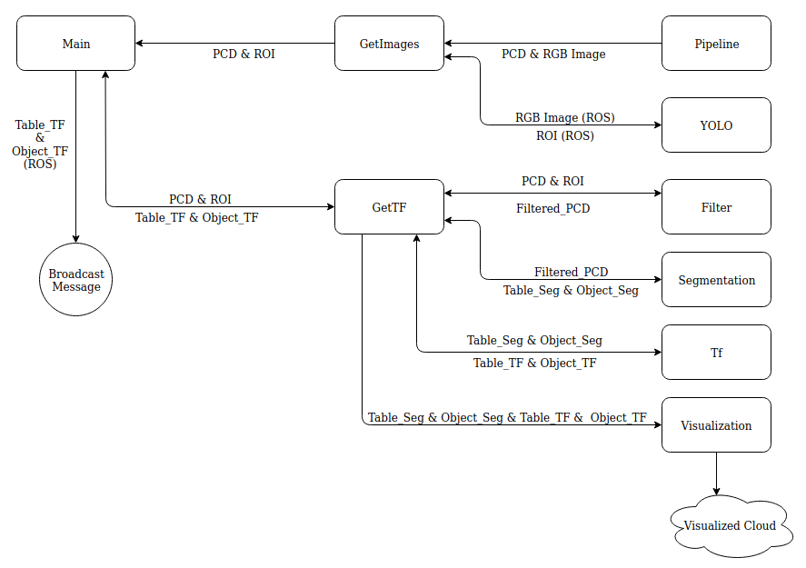

Figure : DFD

## 

## 5.2 Class diagram

As mentioned, the classes are only showed separately. For the full overview on GitHub. The class diagram can be found in the “docs” folder. (GitHub 2019a)

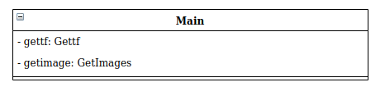

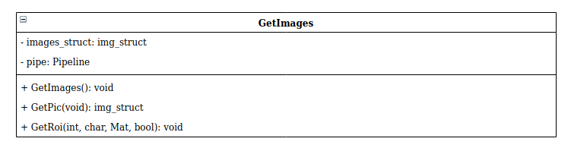

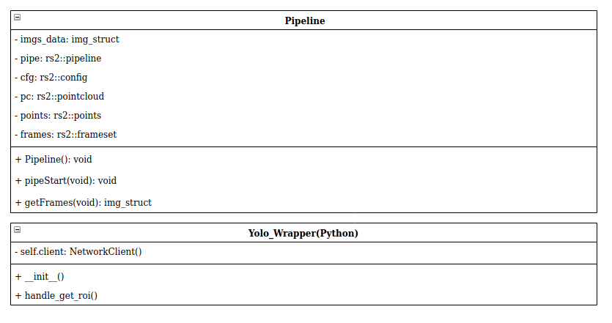

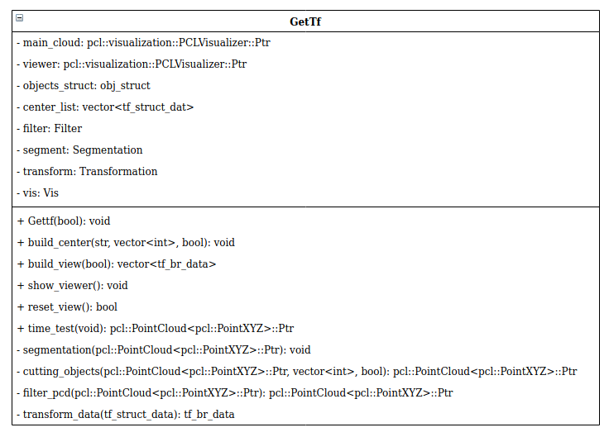

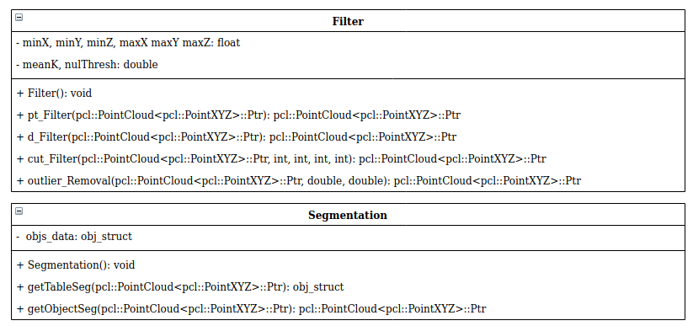

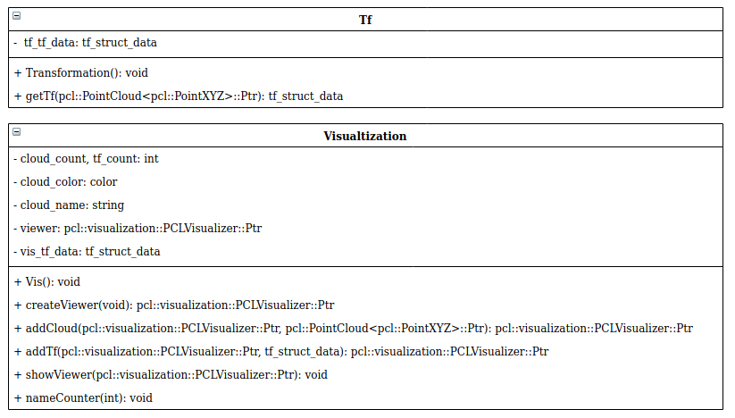

Figure : Class diagram

# Software

The software is designed and programmed as modular as possible. The type of actions, like segmentation or filtering, are separated in classes. Per class, every functional aspect is divided in different functions in that class, which can be used by other pieces of code. The mid-level software, GetImages and GetTf, use the low level classes and their function to perform task, requested by the high level, in our case Main. Doing this, enables a user to easily change structures in the program and changing how it operates. By designing the software modular, requirement 6 is achieved: The software must be modular so that it can be used for multiple purposes.

## 6.1 Main

The main program called “main” will use the classes GetTf and GetImages to get the transformations of objects. “Main” is only created to test and use our software as a separate module. Later this “Main” program can be replaced by software of RoboHub Eindhoven to integrate the 3D-vision solution in their robotic systems.

## 6.2 GetImages

“GetImages” is the class that retrieves the PC and ROI of the objects. It uses the class “Pipeline” and the YOLO_Wrapper for the interaction with YOLO. “GetImages” contains public functions which are accessible for other classes. These functions are used to get the PC and ROI of the objects. The public functions in this class will be shortly explained below.

**GetImages:**

This is the constructor of the GetImages class and is executed if the “Main” class creates an object of the class “GetImages”. The constructor will start the camera so the images can be retrieved.

**GetPic:**

This function returns a struct that contains an RGB image and a PC.

**GetRoi:**

This function uses the RGB image that has been retrieved via GetPic to find the object ROI’ s with YOLO. Those ROI values are returned within a vector. The ROI values consist of: Object name, X pixel top left, Y pixel top left, X pixel bottom right, Y pixel bottom right.

## 6.3 Pipeline

The “Pipeline” class is used to get the RGB image and PC from the camera. The functions in this class will shortly be explained below.

**Pipeline:**

This is the constructor of the “Pipeline” class and is executed if an object is created of the “Pipeline” class. The constructor only prints that it is created so the user knows the process is done.

**PipeStart:**

This function starts and configures the camera. The resolution of every video stream can be changed here.

**GetFrames:**

This function retrieves the RGB image and PC from the camera and returns a struct that contains this data.

## 6.4 Yolo_Wrapper

The yolo_wrapper is the part where the code of RoboHub Eindhoven is reused. As described in paragraph 4.9.2 Communication with YOLO, a communication between C++ and python3 is required. The yolo_wrapper is the part which enables this communication. The yolo_wrapper retrieves an image from GetImages, and returns the ROI’s of all the objects found in the image. For more detailed information please check paragraph 4.9.2 Communication with YOLO.

## 6.5 GetTf

“ GetTf” is the class that will get the transformations of objects. It uses the classes “Filter”, “Segmentation”, “TF” and “Visualization” to complete this task. “GetTf” contains public functions which are accessible for other classes. These functions are used to get the TF of objects. In this case the “Main” class can call these functions to perform the required tasks. The public functions in this class will be shortly explained below.

**Gettf:**

This is the constructor of the GetTf class and is executed if the “Main” class creates an object of the class “GetTf”. The constructor will create a viewer which is internally used in the “GetTf” class.

**Build_center:**

This function calculates the TF of a given object. For getting the TF of objects, it starts cutting out the requested part of a PC. This is done using the “Filter” class and uses the input ROI of YOLO to calculate which part needs to be cut from the PCD. Then the cut PCD can further be filtered PCD using the “Filter” class. More explanation about the filters can be found in paragraph 4.5 Filtering. Now the software can segment the objects and extract them from the table. This is done using the “Segmentation class”. Finally, the segmented PCD is used to calculate the TF using the “TF” class. The results of the TF and the PCD can be added to the viewer. The same process is used for getting the table TF, but with some differences. It doesn’t need the “cutting_objects” function and uses another output of the segmentation function. Segmentation will be discussed in paragraph 6.7 Segmentation. All the TF results are saved in a vector of a custom data type “tf_br_data”.

**Build_view:**

This function returns the TF vector created by the “build_center” function containing objects TF’s and the table TF. Using this function, requirement 9 is achieved: There needs to be a function for getting the table height.

**Show_viewer:**

This function shows the viewer created in “Gettf” and filled by “build_center”.

**Reset_view:**

This function clears the TF vector.

**Time_test:**

This function is purely for testing the speed of sending a PCD. It will just return a PCD.

## 6.6 Filter

The “Filter” class is used to filter the PC for changing the PC, improving the quality of the PC or reducing the amount of points. The functions in this class will shortly be explained below.

**Filter:**

This is the constructor of the “Filter” class and is executed if an object is created of the “Filter” class. The constructor only prints that it is created so the user knows the process is done.

**Pt_Filter:**

This function returns a PC that is filtered with a Passthrough filter. In this filter the minX, maxX, minY, maxY, minZ and maxZ can be changed to define another region.

**D_Filter:**

This function returns a PC that is down sampled. In this filter the LeafSize can be changed for better results. The LeafSize sets the size of the voxel. A voxel can be seen as a 3D box.

**Cut_Filter:**

This function returns a PC with only the points within a defined ROI.

**Outlier_Removal:**

This function returns a PC were the outliers are removed. In this filter the MeanK or mulThresh can be changed for better results. The MeanK is the amount of point that is used for mean distance estimation. mulThresh is the standard deviation multiplier for the distance threshold calculation.

## 6.7 Segmentation

The “Segmentation” class is used to separate objects from the table and from each other. The functions in this class will shortly be explained below.

**Segmentation:**

This is the constructor of the “segmentation” class and is executed if an object is created of the “Segmentation” class. The constructor only prints that it is created so the user knows the process is done.

**GetTableSeg:**

This function will search the table in a PCD. It checks for the biggest plane in a PCD. In the case of RoboHub Eindhoven, this will always be the table. It extracts the table form the PCD leaving the remaining parts being the objects. Both saved in a separate PCD, one for the table, one for the objects. To finetune parameters, setMaxIterations() and setDistanceThreshold() can be changed. setDistanceThreshhold() is the distance how close points need to be to the model in order te be condered as inlier, meaning is belongs to the model. setMaxIterations() is the maximum number of iterations this function will run before giving up. For more information about segmentation, please check paragraph 4.6 Segmentation.

**GetObjectSeg:**

This function will look in PCD for clusters which are the objects. The “GetTf” class will send the cut PCD, discussed in paragraph 6.5 GetTf, to the “getObjectSeg” function. The function will get the biggest cluster found, being the object, and return it. To finetune parameters, setClusterTolerance(), setMinClusterSize(), setMaxClusterSize() can be changed. setClusterTolerance() is the sensitivity for clustering objects. When setting the parameter too low, it can happen that an object can be seen as multiple objects. If the value is too high, multiple objects can be seen as one. setMinClusterSize() sets the minimum number of points a cluster needs to contain to be considered valid. setMaxClusterSize() sets the maximum number of points a cluster needs to contain to be considered valid. For more information about segmentation, please check paragraph 4.6 Segmentation.

## 6.8 Tf

The “Tf” class calculates the TF of a PCD. The functions in this class will shortly be explained below.

**Transformation:**

This is the constructor of the “Tf” class and is executed if an object is created of the “Tf” class. The constructor only prints that it is created so the user knows the process is done.

**GetTf:**

This function does all the calculation to get a TF of an object. The “GetTf” class inputs a PCD to this function. The “getTf” function will calculate the TF and puts the data in a variable of a custom datatype called “tf_struct_data”.

## 6.9 Visualization

The “Visualization” class is used for displaying the results in a viewer. This is used to interface the result of the software with the user. he functions in this class will shortly be explained below.

**Vis:**

This is the constructor of the “Visualization” class and is executed if an object is created of the “Visualization” class. The constructor sets certain color values. These values are used when adding a PCD in the visualizer. Furthermore, some more variable values are set, and a message is printed to the console, so the user know it successfully created an object of the “Visualization” class.

The public functions are shortly described below:

**CreateViewer:**

This function creates an empty viewer which will be filled later with PCD’s and TF’s.

**AddCloud:**

This function adds clouds to the viewer and changes the color of every cloud added to the viewer.

**AddTf:**

This function adds the given TF’s to the viewer.

**ShowViewer:**

This function shows the viewer.

# Measurement results/ testing

## 7.1 Test description

Before running the tests, there has been written a test plan to describe what to test, the requirements to test and how to test. The test plan can be found in Appendix D: Test Plan. The same objects are used as in the 2D vision test that can be found on the RoboHub Eindhoven wiki (GitHub 2019b).

The results of the wiki are compared with the results that come out of the 3D vision solution test and are displayed in 7.2 Accuracy X,Y,Z and Theta.

The 3D vision test will be used to find the difference in accuracy of the 3D vision system in comparison with the 2D vision system. Also, the accuracy in Z-axis and angle Theta of the object will be tested.

For the tests, only one object at a time is detected. Resulting in succeeding requirement 3: Only one RoboCup@Work object will be present on a table per scan to test our system.

## 7.2 Accuracy X,Y,Z and Theta

### 7.2.1 Axis

The graph below shows the accuracy results in the X and Y direction:

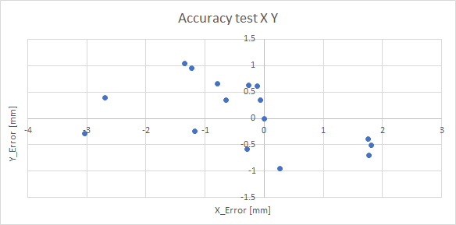

Figure : Result axis

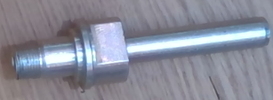Comparison results 2D and 3D-vision:

Figure 21: Axis

|  |  |  |
| --- | --- | --- |
|  | 2D-vision  Error | 3D-vision  Error |
| Standard deviation X [mm] | 14.04 | 1.21 |
| Standard deviation Y [mm] | 40.93 | 0.98 |
| Standard deviation Z [mm] | - | 0.15 |
| Standard deviation Theta [°] | - | 2.60 |

Table : Result axis

**Conclusion:**

3D-vision results in a better accuracy for the X and Y direction. In 2D-vision, the problem for the Axis was the shiny surface of the object, which influenced the results. With the IR approach of the 3D-vision camera, this isn’t a problem anymore. The z direction results in great accuracy due to the stable PCD results of the camera because of the objects color. Due to the bigger length in rate with the width the theta is good. The foundation of the theta conclusion is explained in Appendix B: Theta explanation.

### 7.2.2 Bearing

The graph below shows the accuracy results in the X and Y direction:

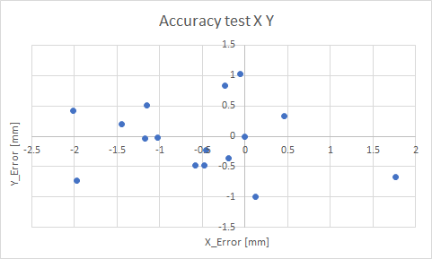

Figure : Result bearing

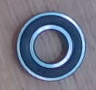Comparison results 2D and 3D-vision:

Figure 23: Bearing

|  |  |  |
| --- | --- | --- |
|  | 2D-vision  Error | 3D-vision  Error |
| Standard deviation X [mm] | 0.89 | 0.92 |
| Standard deviation Y [mm] | 1.38 | 0.55 |
| Standard deviation Z [mm] | - | 0.38 |
| Standard deviation Theta [°] | - | - |

Table : Result bearing

**Conclusion:**

The results of the 2D and 3D-vision solution are approximately the same. In the X direction 2D scored better, where 3D scored better in the Y-direction. For 2D-vision, the advantage of this object is that it also contains a black ring on the surface. For 3D-vision, the advantage of this object is that is has also a silver ringed part on the surface. The standard deviation in the Z direction is great due to the objects flat surface. The Theta isn’t measured because it is a round object, meaning it isn’t important how the robot will grab the object.

### 7.2.3 Bearing box

The graph below shows the accuracy results in the X and Y direction:

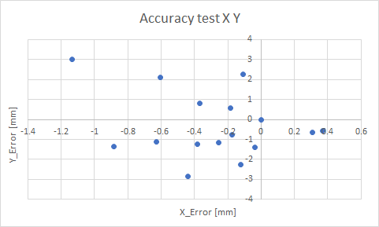

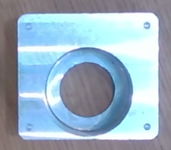Figure : Result bearing box

Comparison results 2D and 3D-vision:

|  |  |  |
| --- | --- | --- |
|  | 2D-vision  Error | 3D-vision  Error |
| Standard deviation X [mm] | 9.79 | 0.38 |
| Standard deviation Y [mm] | 8.95 | 1.60 |
| Standard deviation Z [mm] | - | 0.34 |
| Standard deviation Theta [°] | - | 11.92 |

Table : Result bearing box

Figure 25: Bearing box

**Conclusion:**

The conclusion for this object is the same as the axis in the X, Y and Z direction, paragraph 7.2.1 Axis. The theta in comparison with the axis, is worse. This is because of the shape of the object. The shape of the bearing box is almost like a square, meaning a difference in the PCD in the length or width, will influence the theta more than with a more rectangle like shaped object. For more information of this foundation please check Appendix B: Theta explanation.

### 7.2.4 Big black profile

The graph below shows the accuracy results in the X and Y direction:

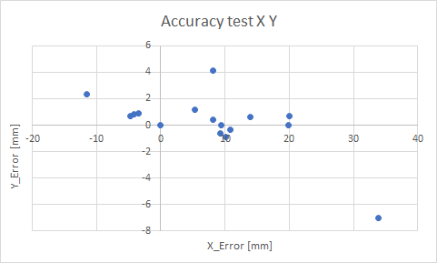

Figure : Result big black profile

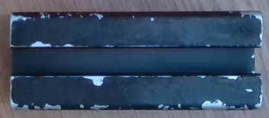Comparison results 2D and 3D-vision:

Figure 27: Big black profile

|  |  |  |
| --- | --- | --- |
|  | 2D-vision  Error | 3D-vision  Error |
| Standard deviation X [mm] | 0.86 | 10.89 |
| Standard deviation Y [mm] | 0.86 | 2.18 |
| Standard deviation Z [mm] | - | 0.12 |
| Standard deviation Theta [°] | - | 1.16 |

Table : Result big black profile

**Conclusion:**

The 3D-vision resulted in a worse accuracy in the X and Y direction. This is due to the working principle of the 3D-camera, descripted in paragraph 4.4.1 Research pipeline. The black/ dark material of the object will absorb the IR-light, making these object more instable for getting a smooth PC. The Z direction has a good result, due to the flat surface of the object. The theta has a good result due to the rate between the length and the width of the object, described in Appendix B: Theta explanation. The issue with the black object is shown in Figure 28.

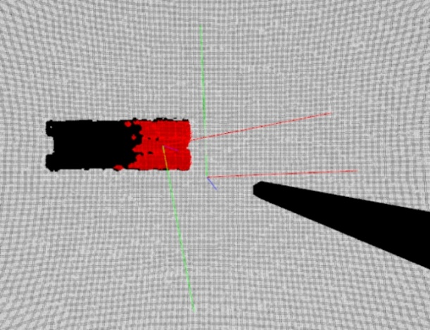

Figure : Big black profile issue

### 7.2.5 Big nut

The graph below shows the accuracy results in the X and Y direction:

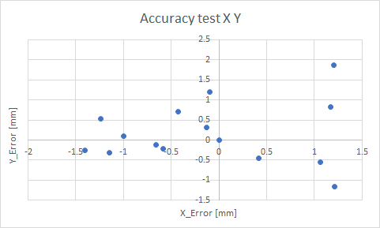

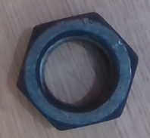Figure : Result big nut

Comparison results 2D and 3D-vision:

|  |  |  |
| --- | --- | --- |
|  | 2D-vision  Error | 3D-vision  Error |
| Standard deviation X [mm] | 0.83 | 0.90 |
| Standard deviation Y [mm] | 0.71 | 0.74 |
| Standard deviation Z [mm] | - | 0.16 |
| Standard deviation Theta [°] | - | - |

Table : Result big nut

Figure 30: Big nut

**Conclusion:**

The results between 2D and 3D-vision are approximately the same. The 2D-vision scored a bit better due to the dark surface of the object. Due to the flat surface of the object, the Z direction has stable accuracy results. The theta isn’t calculated because of the six equal sides of the object. The six sides enable the gripper to pick the object in multiple ways, so the rotational precision is less important. The equal sides also give the same problem as described in Appendix B: Theta explanation.

### 7.2.6 Distance tube

The distance tube was not recognized by the segmentation algorithm with the current filter values. The object is too small to be detected and is seen as table, see Figure 31. This could be solved when YOLO is fully integrated and other, more aggressive, filter values can be used. By now there is no data that can be compared with the 2D vision test results. The issue of the distance tube is showed in Figure 32.

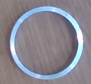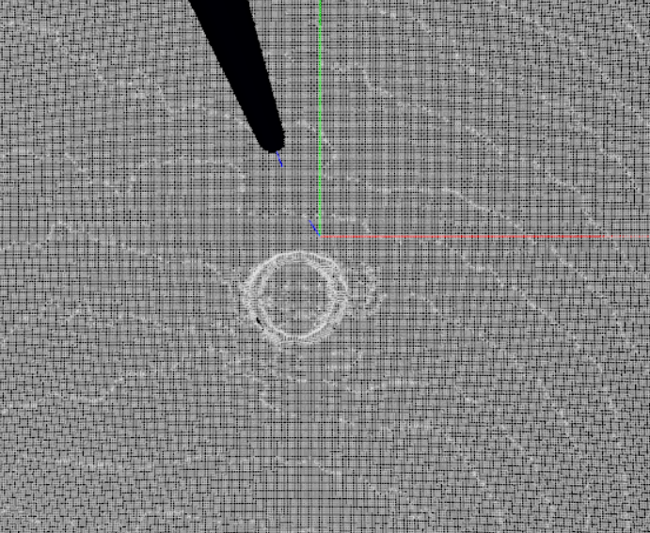

Figure 31: Distance tube

Figure : Distance tube issue

### 7.2.7 Motor

The graph below shows the accuracy results in the X and Y direction:

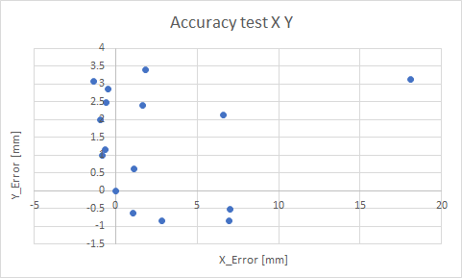

Figure : Result motor

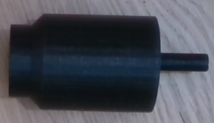Comparison results 2D and 3D-vision:

Figure 34: Motor

|  |  |  |
| --- | --- | --- |
|  | 2D-vision  Error | 3D-vision  Error |
| Standard deviation X [mm] | 1.92 | 4.86 |
| Standard deviation Y [mm] | 3.29 | 1.49 |
| Standard deviation Z [mm] | - | 2.50 |
| Standard deviation Theta [°] | - | 9.74 |

Table : Result motor

**Conclusion:**

The 3D-vision solution scored worse in the X direction and the 2D-vision solution scored worse in the Y direction. Because of the asymmetric shape of the motor, the place on the table and the rotation of the object, determines the measured length of the object. Due to the changes in length, the CenterPoint of the X and Y will change. Depending on how the object is placed under the camera, determines in which direction is the biggest offset. Expected is that with the 2D-vision, the motor is rotated 90° compare to the 3D-vision solution measurements. For the foundation of this conclusion, please check Appendix C: Asymmetric objects. Due to the shape and the color of the object, also the Z direction is influenced badly. The closer the motor came to the camera, the more PC data we got from the motor Figure 1, the more of the round shape was found, changing the surface for the Z direction. The variation in theta, is explained in Appendix B: Theta explanation. The images of the Z axis problem are shown below. Figure 36 showing the result when the object was far away from the camera in Z direction. Figure 35 showing the result when the object was close by the camera in Z direction.

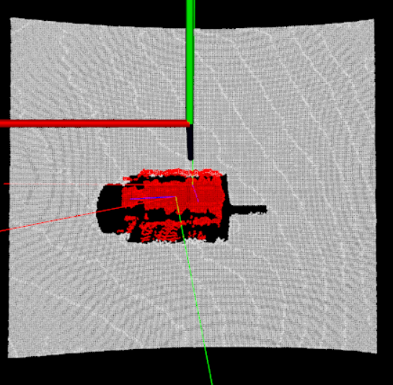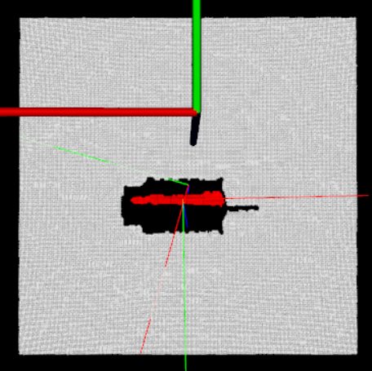

Figure 35: Motor Z issue close by

Figure : Motor Z issue far away

### 7.2.8 R20

The graph below shows the accuracy results in the X and Y direction:

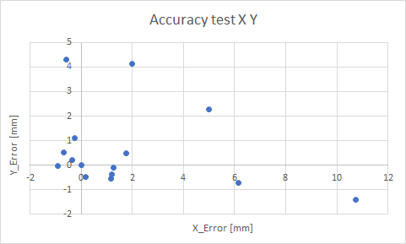

Figure : Result R20

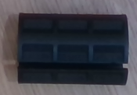Comparison results 2D and 3D-vision:

Figure 38: R20

|  |  |  |
| --- | --- | --- |
|  | 2D-vision  Error | 3D-vision  Error |
| Standard deviation X [mm] | 0.87 | 3.10 |
| Standard deviation Y [mm] | 1.44 | 1.63 |
| Standard deviation Z [mm] | - | 0.63 |
| Standard deviation Theta [°] | - | 4.88 |

Table : Result R20

**Conclusion:**

The 3D-vision solution shows to get worse results compared to the 2D-vision solution. This is due to the black material of the object. Giving 2D-vision an advantage and 3D-vision a disadvantage. The height in z differs also due to the black material. When the object gets closer to the camera, it sees more of the object. Because it is a round black tube, the software will see more of the round shape, changing the center in the Z direction. The theta differs due to the black material and the small and almost square size of the object.

### 7.2.9 Small aluminum profile

The graph below shows the accuracy results in the X and Y direction:

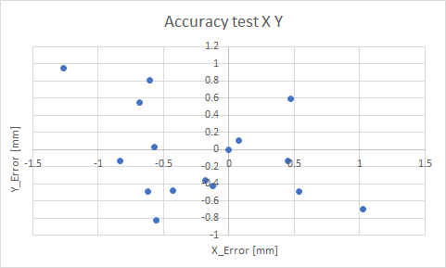

Figure : Result small aluminum profile

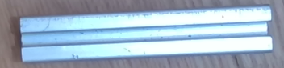Comparison results 2D and 3D-vision:

Figure 40: Small aluminum profile

|  |  |  |
| --- | --- | --- |
|  | 2D-vision  Error | 3D-vision  Error |
| Standard deviation X [mm] | 8.45 | 0.58 |
| Standard deviation Y [mm] | 1.42 | 0.52 |
| Standard deviation Z [mm] | - | 0.05 |
| Standard deviation Theta [°] | - | 0.79 |

Table : Result small aluminum profile

**Conclusion:**

The 3D-vision solution scored better with the small aluminum profile compared to the 2D-vsion solution. This is due to the color of the object, giving the 3D-vision solution an advantage and the 2D-vision solution a disadvantage. The Z direction scored well due to the flat surface of the object and the clear PCD due to the color of the object. The Theta is good due to the shape of the object, explained in Appendix B: Theta explanation.

### 7.2.10 Small black profile

The graph below shows the accuracy results in the X and Y direction:

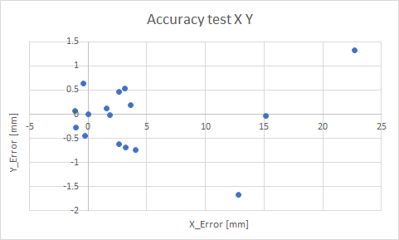

Figure : Result small black profile

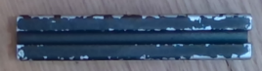Comparison results 2D and 3D-vision:

Figure 42: Small black profile

|  |  |  |
| --- | --- | --- |
|  | 2D-vision  Error | 3D-vision  Error |
| Standard deviation X [mm] | - | 6.47 |
| Standard deviation Y [mm] | - | 0.67 |
| Standard deviation Z [mm] | - | 0.15 |
| Standard deviation Theta [°] | - | 0.63 |

Table : Result small black profile

**Conclusion:**

Since RoboHub Eindhoven didn’t test this object, the result are not compared. The standard deviation in the X direction is 6.47 mm. This is due to the color of the object. Since the object lay in the x direction, the camera had a hard time seeing the whole object in the X direction, resulting in fluctuating outcomes. The Z is well due to the flat surface of the object. The theta is good due to the size of the object, explained in Appendix B: Theta explanation.

### 7.2.11 Small nut

The graph below shows the accuracy results in the X and Y direction:

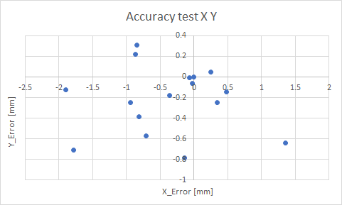

Figure : Result small nut

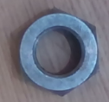Comparison results 2D and 3D-vision:

Figure 44: Small nut

|  |  |  |
| --- | --- | --- |
|  | 2D-vision  Error | 3D-vision  Error |
| Standard deviation X [mm] | 0.98 | 0.81 |
| Standard deviation Y [mm] | 1.31 | 0.31 |
| Standard deviation Z [mm] | - | 0.77 |
| Standard deviation Theta [°] | - | - |

Table : Result small nut

**Conclusion:**

The small nut resulted better in the 3D-vision solution, due to the shiny glance of the surface of the object. The Z direction is good due to the flat top surface. The Theta is not calculated due to the same explanation given in paragraph 7.2.5 Big nut.

# Final status

Currently the software is finished for getting the table TF and an object TF with scanning one object at a time as described in requirement 3, without object detection. This software is used in for testing the accuracy described in chapter 7. Furthermore, integrating object detection is in progress and is not fully finished. The following problems are being encountered during the development of this part.

*Offset Cut_Filter:*

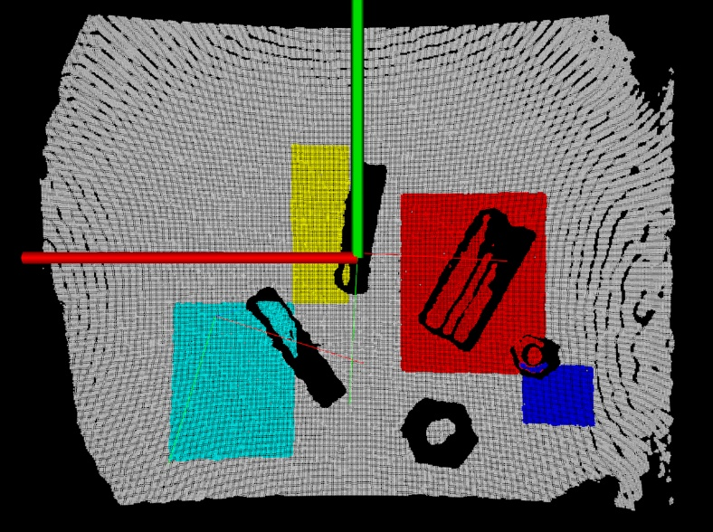The Cut_Filter cuts out a piece of the PC. The cutting dimensions are given by YOLO ROI’s. Unfortunately, the current Cut_Filter has an offset compared to the ROI’s given by YOLO. This is because the camera that is used for YOLO is not the same camera that makes the PC and the algorithm is based on having the cameras on the same place. The PC that goes into the segmentation algorithm is wrong due to this offset. This also means the output of the segmentation algorithm and calculation of the TF’s are wrong. The output of the Cut_Filter can be seen in Figure 46. It is clearly visible that the Cut_Filter shifted the ROI that is given. Only the yellow ROI seems to be good. After rerunning the code after we moved the objects, the same thing happened. All ROI’s are shifted, only the object that is approximately on the same place as the yellow ROI of Figure 46 has a correct ROI. This can be seen in Figure 45.

Figure 45: Offset ROI after rerunning Cut_Filter with moved objects

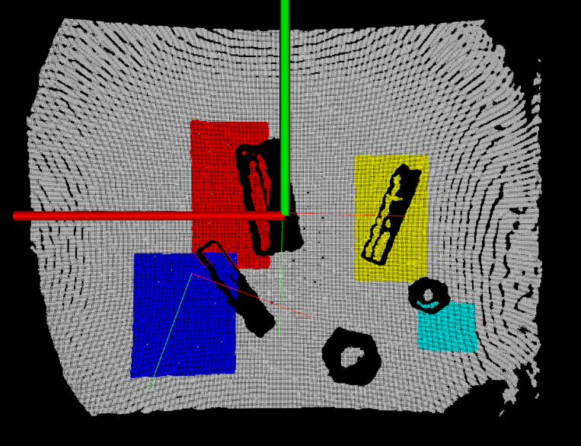

Figure 46: Offset ROI after Cut_Filter

*Optimizing filters/segmentation:*

This still needs to be done after the YOLO part is fully integrated and working. When the filter/segmentation values are changed, this affects the entire system. This way parts of objects fall away, or parts of the table are seen as objects. When YOLO is integrated every object can have its own and most optimal filter values according to the output of the YOLO network.

Table 16 contains an overview of the requirements and whether they have been achieved or not. In the last column of the table the chapter is mentioned that describes the foundation of the achieving the requirements.

|  |  |  |
| --- | --- | --- |
| Requirement | Achieved | Chapter |
| 1. The camera that needs to be used is the BlasterX Senz3D from Creative | Yes | 4.4.1 Research pipeline |
| 1. It must be possible to broadcast a TF of every RoboCup@Work object | No | 9. Conclusion |
| 1. Only one RoboCup@Work object will be present on a table per scan to test our system | Yes | 7 Measurement result/ testing |
| 1. The software needs to be written in C++ or Python | Yes | 4.3 C++ tutorials |
| 1. The system needs to work on a scan height between 20 and 40 cm’s. Parallel to the table surface | Yes | 4.4.1 Research pipeline |
| 1. The software must be modular so that it can be used for multiple purposes | Yes | 6. Software |
| 1. Software is published on the GitHub of RoboHub Eindhoven and a wiki is written for it | Yes | (GitHub 2019a), will later go to (GitHub2019b) |
| 1. The 3D system needs to be more accurate than the 2D system that is made last year by RoboHub Eindhoven | No | 9. Conclusion |
| 1. There needs to be a function for getting the table height | Yes | 6.5 GetTf |
| 1. Researching object detection for 3D vision | Yes | 4.4.1 Research pipeline |

Table : Overview requirements

# Conclusions

RoboHub Eindhoven developed a 2D-vision system, which determines the orientation and rotation of an object. They encountered multiple problems in this solution. The biggest problem is that the 2D-vision solution not able is to measure the depth of the objects or the tables, causing the robotic systems to be blind in de Z direction (the depth). Also, it is hard for this solution to detect shiny surfaced objects, and objects with the same color as the background. The last problem was the light dependency of the solution. The ambient light influenced the results greatly. The goal for this project is to create a 3D-vision solution, which determines the transformation of objects and the table and integrate it in ROS to publish the transformations.

The goal to create a 3D-vision solution which can determine the transformation of objects and the table is succeeded. In comparison to the requirement, mandatory requirement 2 and variable requirement 8 are not successfully achieved. Requirement 2 describes, it must be possible to broadcast a TF of every RoboCup@Work object. The software in combination with the 3D-camera was not able to see the difference between one of the objects, the distance tube, and the table. This is because of the small size of the object whereby the object is detected as table and couldn’t be separated. The variable requirement 8 describes that the 3D system needs to be more accurate than the 2D system that is developed by RoboHub Eindhoven. Comparing the 3D-vision with the 2D-vision solution, seemed to be depending on the object which system is more accurate. This is compared only for the orientation of the object since RoboHub Eindhoven only tested the orientation outcome. For shiny and all non-black objects, the 3D-vision scored better since the 3D-vision uses IR to scan objects and isn’t affected by the shiny surfaces. The 2D-vision scored better on black objects since the black material absorbed the IR beams of the 3D-vsion solution which resulted in bad PCD outcomes. The black objects were also an advantage for the 2D-vision solution since it works with the contours of the objects, and the testing surface for the 2D-vision had a white color, making a clear contrast between the object and the background. For the rotation, this wasn’t tested in the 2D-vision test. For the 3D-vision, more rectangle like shaped scored a higher precision in theta, in comparison to more squared or symmetric like shapes.

As a recommendation, fully finishing the software including YOLO is advised. With YOLO integrated, the filter and segmentation algorithm parameters can be finetuned to also detect the distance tube. If this is done, requirement 2 can be succeeded. Combining the 2D-vision solution with the 3D-vision solution can fix the issues with the black objects and optimize the accuracy results. If a black object is detected by YOLO, the 2D-vision should determine the orientation and rotation of the object. The depth can be calculated of the table with 3D-vision. For all other objects, using 3D-vision is advised. Furthermore, finetuning and testing the algorithm parameters will create more accuracy.

List of tables

Table 1: Abbreviations 7

Table 2: Library research 10

Table 3: Basic design 11

Table 4: Filter research 13

Table 5: Segmentation research 16

Table 6: Result axis 31

Table 7: Result bearing 32

Table 8: Result bearing box 33

Table 9: Result big black profile 34

Table 10: Result big nut 35

Table 11: Result motor 37

Table 12: Result R20 38

Table 13: Result small aluminum profile 39

Table 14: Result small black profile 40

Table 15: Result small nut 41

Table 16: Overview requirements 43

Table 17: RoboCup@Work objects 49

Table 18: Checkpoints accuracy angle test 53

List of figures

Figure 1: Basic design 9

Figure 2: Pipeline test 12

Figure 3: YOLO output 12

Figure 4: Camera issue 13

Figure 5: Passthrough and Voxel grid filter input 14

Figure 6: Passthrough filter output 15

Figure 7: Voxel grid filter output 15

[Figure 8: Table segmentation 17](https://stichtingfontys.sharepoint.com/sites/PRJ72/Shared%20Documents/Design_Doc_Mark_Jeroen_v4.docx#_Toc29542264)

[Figure 9: Object segmentation 17](https://stichtingfontys.sharepoint.com/sites/PRJ72/Shared%20Documents/Design_Doc_Mark_Jeroen_v4.docx#_Toc29542265)

Figure 10: TF moment of inertia 18

Figure 11: PCLVisualizer 19

Figure 12: Communication YOLO 21

Figure 13: CvBridge 21

Figure 14: TF broadcaster 22

Figure 15: Euler 23

[Figure 16: TF values from Rviz 23](https://stichtingfontys.sharepoint.com/sites/PRJ72/Shared%20Documents/Design_Doc_Mark_Jeroen_v4.docx#_Toc29542272)

Figure 17: TF values from code 23

Figure 18: DFD 24

Figure 19: Class diagram 26

Figure 20: Result axis 31

[Figure 21: Axis 31](https://stichtingfontys.sharepoint.com/sites/PRJ72/Shared%20Documents/Design_Doc_Mark_Jeroen_v4.docx#_Toc29542277)

Figure 22: Result bearing 32

[Figure 23: Bearing 32](https://stichtingfontys.sharepoint.com/sites/PRJ72/Shared%20Documents/Design_Doc_Mark_Jeroen_v4.docx#_Toc29542279)

Figure 24: Result bearing box 33

[Figure 25: Bearing box 33](https://stichtingfontys.sharepoint.com/sites/PRJ72/Shared%20Documents/Design_Doc_Mark_Jeroen_v4.docx#_Toc29542281)

Figure 26: Result big black profile 34

[Figure 27: Big black profile 34](https://stichtingfontys.sharepoint.com/sites/PRJ72/Shared%20Documents/Design_Doc_Mark_Jeroen_v4.docx#_Toc29542283)

Figure 28: Big black profile issue 34

Figure 29: Result big nut 35

[Figure 30: Big nut 35](https://stichtingfontys.sharepoint.com/sites/PRJ72/Shared%20Documents/Design_Doc_Mark_Jeroen_v4.docx#_Toc29542286)

[Figure 31: Distance tube 36](https://stichtingfontys.sharepoint.com/sites/PRJ72/Shared%20Documents/Design_Doc_Mark_Jeroen_v4.docx#_Toc29542287)

Figure 32: Distance tube issue 36

Figure 33: Result motor 36

[Figure 34: Motor 37](https://stichtingfontys.sharepoint.com/sites/PRJ72/Shared%20Documents/Design_Doc_Mark_Jeroen_v4.docx#_Toc29542290)

[Figure 35: Motor Z issue close by 37](https://stichtingfontys.sharepoint.com/sites/PRJ72/Shared%20Documents/Design_Doc_Mark_Jeroen_v4.docx#_Toc29542291)

Figure 36: Motor Z issue far away 37

Figure 37: Result R20 38

[Figure 38: R20 38](https://stichtingfontys.sharepoint.com/sites/PRJ72/Shared%20Documents/Design_Doc_Mark_Jeroen_v4.docx#_Toc29542294)

Figure 39: Result small aluminum profile 39

[Figure 40: Small aluminum profile 39](https://stichtingfontys.sharepoint.com/sites/PRJ72/Shared%20Documents/Design_Doc_Mark_Jeroen_v4.docx#_Toc29542296)

Figure 41: Result small black profile 40

[Figure 42: Small black profile 40](https://stichtingfontys.sharepoint.com/sites/PRJ72/Shared%20Documents/Design_Doc_Mark_Jeroen_v4.docx#_Toc29542298)

Figure 43: Result small nut 41

[Figure 44: Small nut 41](https://stichtingfontys.sharepoint.com/sites/PRJ72/Shared%20Documents/Design_Doc_Mark_Jeroen_v4.docx#_Toc29542300)

[Figure 45: Offset ROI after rerunning Cut_Filter with moved objects 42](https://stichtingfontys.sharepoint.com/sites/PRJ72/Shared%20Documents/Design_Doc_Mark_Jeroen_v4.docx#_Toc29542301)

[Figure 46: Offset ROI after Cut_Filter 42](https://stichtingfontys.sharepoint.com/sites/PRJ72/Shared%20Documents/Design_Doc_Mark_Jeroen_v4.docx#_Toc29542302)

[Figure 47: Theta explanation 50](https://stichtingfontys.sharepoint.com/sites/PRJ72/Shared%20Documents/Design_Doc_Mark_Jeroen_v4.docx#_Toc29542303)

Figure 48: Asymmetric objects 51

Figure 49: Checkpoints X,Y test 52

Figure 50: Checkpoints accuracy Z-axis test 53

[Figure 51: Setup Accuracy x-axis, y-axis, z-axis test 54](https://stichtingfontys.sharepoint.com/sites/PRJ72/Shared%20Documents/Design_Doc_Mark_Jeroen_v4.docx#_Toc29542307)

[Figure 52: Setup Accuracy x-axis, y-axis, z-axis test 55](https://stichtingfontys.sharepoint.com/sites/PRJ72/Shared%20Documents/Design_Doc_Mark_Jeroen_v4.docx#_Toc29542308)

[Figure 53: Setup Accuracy angle test 56](https://stichtingfontys.sharepoint.com/sites/PRJ72/Shared%20Documents/Design_Doc_Mark_Jeroen_v4.docx#_Toc29542309)

Figure 54: List of tutorials 57

# Reference list

Cmake (2019) Cmake: <https://cmake.org/>

Creative (2019) BlasterX Senz3D: <https://nl.creative.com/p/web-cameras/blasterx-senz3d>

GitHub (2019a) suii_3d_vision_ros: <https://github.com/JeroenBongers96/suii_3d_vision_ros>

GitHub (2019b) RoboHub Eindhoven: <https://github.com/RoboHubEindhoven>

Intel (2018) Intel Realsense SDK 2.0: <https://github.com/IntelRealSense/librealsense>

Pointcloud (2019a) Plane model segmentation: <http://pointclouds.org/documentation/tutorials/planar_segmentation.php#planar-segmentation>

Pointcloud (2019b) Euclidean cluster extraction: <http://pointclouds.org/documentation/tutorials/cluster_extraction.php#cluster-extraction>

Pointcloud (2019c) Moments of Inertia: <http://pointclouds.org/documentation/tutorials/moment_of_inertia.php#moment-of-inertia>

Pointcloud (2019d) GASD: <http://pointclouds.org/documentation/tutorials/gasd_estimation.php#gasd-estimation>

Pointcloud (2019e) PCL visualizer: <http://pointclouds.org/documentation/tutorials/pcl_visualizer.php#pcl-visualizer>

Pointcloud (2019f) Passthrough filter:

<http://pointclouds.org/documentation/tutorials/passthrough.php#passthrough>

Pointcloud (2019g) Voxel grid filter:

<http://pointclouds.org/documentation/tutorials/voxel_grid.php#voxelgrid>

Pointcloud (2019h) Statistical outlier removal:

<http://pointclouds.org/documentation/tutorials/statistical_outlier.php#statistical-outlier-removal>.

ROS (2019a) About ROS: <https://www.ros.org/about-ros/>

ROS (2019b) TF: <http://wiki.ros.org/tf/Tutorials>

ROS (2019c) CvBridge: <http://wiki.ros.org/cv_bridge/Tutorials/UsingCvBridgeToConvertBetweenROSImagesAndOpenCVImages>

ROS (2019d) Writing a Simple Service and Client (C++): <https://wiki.ros.org/ROS/Tutorials/WritingServiceClient%28c%2B%2B%29>

Rviz (2019) Rviz: https://www.theconstructsim.com/ros-5-mins-025-rviz/

Visual Studio code (2019) Visual studio code: <https://code.visualstudio.com/>

Wikipedia (2019a) C++: <https://en.wikipedia.org/wiki/C%2B%2B>

Wikipedia (2019b) Conversion between quaternions and Euler angles: <https://en.wikipedia.org/wiki/Conversion_between_quaternions_and_Euler_angles>

Wikipedia (2019c) Normal (geometry): <https://en.wikipedia.org/wiki/Normal_(geometry)>

YOLO (2018) Real-Time Object Detection: <https://pjreddie.com/darknet/yolo/>

# Appendix

## Appendix A: RoboCup@Work objects

In the table below, the RuboCup@work objects are listed with their measurements. Also, a column is added if the objects where available at RoboHub Eindhoven for testing purpose.

|  |  |  |  |
| --- | --- | --- | --- |
| **Object** | **Measurement** | **Unit** | **Availability** |
| Axis | 27 x 96 | D [mm] x L [mm] | Yes |
| Bearing | 13 x 15 x 32 | H [mm] x Di [mm] x Do [mm] | Yes |
| Bearing box | 25 x 45 x 50 x 32 | H [mm] x W [mm] x L [mm] x Di [mm] | Yes |
| Big aluminum profile | 40 x 40 x 100 | H [mm] x W [mm] x L [mm] | No |
| Big black profile | 40 x 40 x 100 | H [mm] x W [mm] x L [mm] | Yes |
| Big nut | 30 | ISO [M] | Yes |
| Bolt | 20 x 100 | ISO [M] x L [mm] | No |
| Distance tube | 10 x 28 x 32 | H [mm] x Di [mm] x Do [mm] | Yes |
| Motor | 42 x 87 | D [mm] x L [mm] | Yes |
| R20 | 20 x 30 x 45 | Di [mm] x Do [mm] x L [mm] | Yes |
| Small aluminum profile | 20 x 20 x 100 | H [mm] x W [mm] x L [mm] | Yes |
| Small black profile | 20 x 20 x 100 | H [mm] x W [mm] x L [mm] | Yes |
| Small nut | 20 | ISO [M] | Yes |

Table : RoboCup@Work objects

## Appendix B: Theta explanation

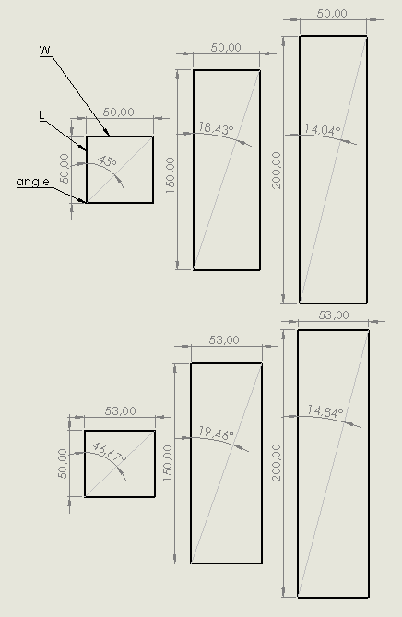In Figure 47, three object shapes are compared to the same shape with a different width (w). The length (l) of the objects remain the same. Shown here, is a difference of 3 mm in width. The results show the increasing difference for the measured angles. For the first object, the square, increasing the width influences the angel with a difference of 1.67°. For the second object, the rectangle, with a 3 times bigger length than the square, the angle differs only 1.03°. for the third object, the rectangle with a length, 4 times the length of the square, the difference in angle is 0.8°. To conclude, how bigger the proportion of the length in comparison to the width, the less impact the difference in the width will influence the angle.

Figure 47: Theta explanation

## Appendix C: Asymmetric objects

In Figure 48, the problem of the offset in linear direction is shown. The direction can be X or Y, depending on how the camera is set in comparison to the object. As you can see, the lines 1 and 2, representing IR beams, touch both a part of the object. But in line 3, we see that on the right side, the object is measured, but at the left side it doesn’t see the object. This is meaning that the software measures a “shorter” object on the left side. This results in a shift of the center of the measured right object, compared to the left object.

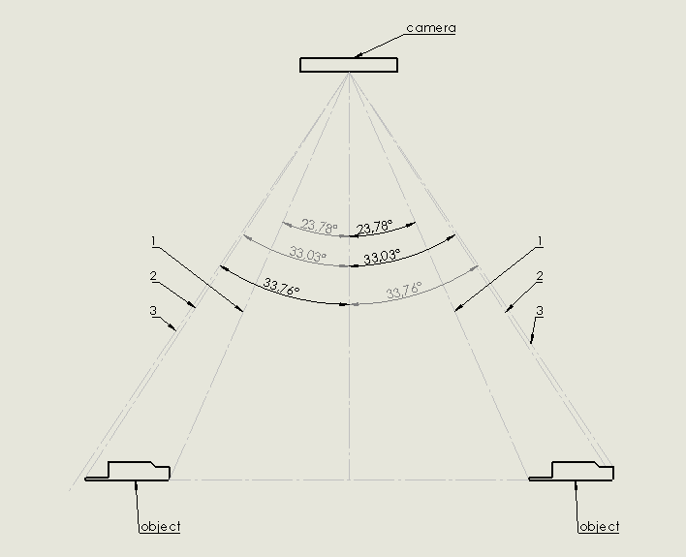

Figure : Asymmetric objects

## Appendix D: Test Plan

What to test:

* Accuracy x-axis, y-axis
* Accuracy z-axis
* Accuracy angle

List of RoboCup objects:

* Axis
* Bearing
* Bearing box
* Big aluminum profile
* Big black profile
* Big nut
* Bolt
* Distance tube
* Motor
* R20
* Small aluminum profile
* Small black profile
* Small nut

Checkpoints accuracy x-axis, y-axis test:

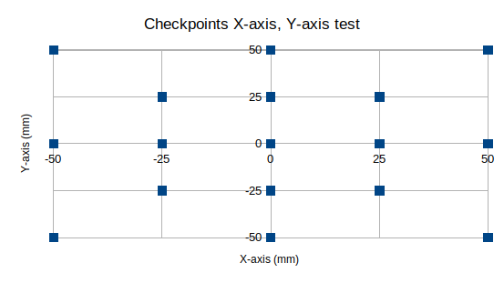

Figure : Checkpoints X,Y test

Checkpoints accuracy z-axis test:

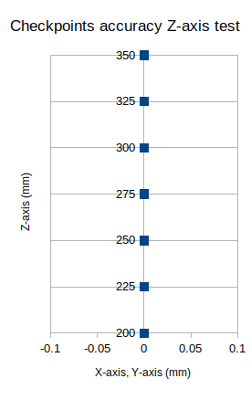

Figure : Checkpoints accuracy Z-axis test

Checkpoints accuracy angle test:

|  |  |  |  |  |  |  |  |  |  |  |  |  |
| --- | --- | --- | --- | --- | --- | --- | --- | --- | --- | --- | --- | --- |
| Change in Angle (°) | 0 | 30 | 60 | 90 | 120 | 150 | 180 | 210 | 240 | 270 | 300 | 330 |

Table : Checkpoints accuracy angle test

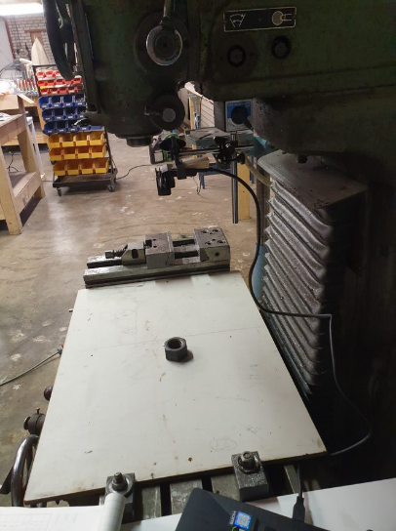**Accuracy x-axis, y-axis**

The objects we need for this test:

* Camera
* All RoboCup objects
* Milling machine (accuracy of three decimal spaces)
* Wooden plank
* Double sided tape

**Setup:**  
We attach the camera to a fixed point of the milling machine so that it can see the movable bed of the milling machine. On top of the bed of the milling machine we put a wooden plank, so the bed is level. One of the RoboCup objects gets attached with double sided tape to the wooden plank so it can’ t move while testing. The distance from camera to table needs to be +/-40 cm while running this test. The setup for this test can be seen in Figure 51 and Figure 52.

Figure 51: Setup Accuracy x-axis, y-axis, z-axis test

**How to test:**

Make a 3d scan of the object when it lays around the middle of the camera view. After this move the bed in the cross pattern (like shown in Figure 49) and make a scan in every point of this cross pattern. The first result is used as reference. We will move the bed x and y cm. We calculate the difference in the outcome of the results and compare it with the real movements we made to determine the precision of our system.

After all scans are made, attach another RoboCup object to the wooden plank and repeat the same test with this other object. Repeat this for all RoboCup objects.

After the test we can calculate the deviation in x and y-axis of every object.

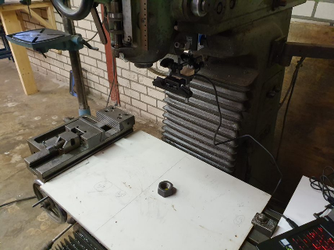**Accuracy z-axis**

The objects we need for this test:

* Camera
* All RoboCup objects
* Milling machine (accuracy of three decimal spaces)
* Wooden plank
* Double sided tape

**Setup:**  
We attach the camera to a fixed point of the milling machine so that it can see the movable bed of the milling machine. On top of the bed of the milling machine we put a wooden plank, so the bed is level. The setup for this test can be seen in Figure 51 and Figure 52.

Figure 52: Setup Accuracy x-axis, y-axis, z-axis test

**How to test:**

Make a 3d scan of just the bed. After this change the height of the bed (like shown in Figure 50) and make a scan. Repeat this process for all heights shown in graph Y (range of 20-35 cm table to camera distance). The first result is used as reference. We calculate the difference in the outcome of the results and compare it with the real movements that are made to determine the precision of our system. After the test we can calculate the deviation in z-axis for our system.

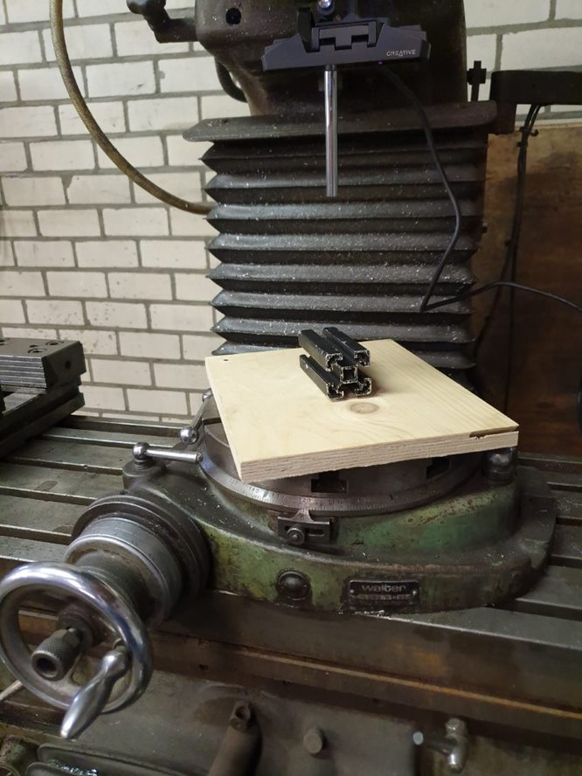**Accuracy angle**

The objects we need for this test:

* Camera
* Multiple RoboCup objects
* Milling machine (accuracy of three decimal spaces)
* Rotary table
* Wooden plank
* Double sided tape

**Setup:**

We attach the camera to a fixed point of the milling machine so that it can see the movable bed of the milling machine. On top of the bed of the milling machine we attach a rotary table so we can give the object a known angle. On top of this rotary table we attach the wooden plank, so the bed is level. One of the RoboCup objects gets attached with double sided tape to the wooden plank so it can’ t move while testing. The distance from camera to table needs to be +/-40 cm while running this test. The setup for this test can be seen in Figure 53.

Figure 53: Setup Accuracy angle test

**How to test:**

Make a 3d scan of the object when it lays around the middle of the camera view. After that change the angle of the bed with the rotary table (Like show in Table 18) and make a new scan. The first result is used as reference. We calculate the difference in the outcome of the results and compare it with the real movements we made to determine the precision of our system. After all scans are made, attach another RoboCup object to the wooden plank and repeat the same test with this other object. Repeat this for all RoboCup objects. After the test we can calculate the deviation in angle for our system.

## Appendix E: List of tutorials

Below all used tutorials are listed with the link included.

|  |  |  |
| --- | --- | --- |
| **Chapter** | **Subject** | **Link to reference list** |
| 4.5 Filtering | Passthrough filter tutorial | Pointcloud 2019f |
| 4.5 Filtering | Voxel grid filter tutorial | Pointcloud 2019g |
| 4.5 Filtering | Statistical outlier removal tutorial | Pointcloud 2019h |
| 4.6 Segmentation | Plane model segmentation tutorial | Pointcloud 2019a |
| 4.6 Segmentation | Euclidean cluster extraction tutorial | Pointcloud 2019b |
| 4.7 TF | Moments of Inertia | Pointcloud 2019c |
| 4.8 Visualizer | PCL visualizer | Pointcloud 2019e |
| 4.9.3 ROS services | CvBridge | ROS 2019c |
| 4.9.3 ROS services | Writing a Simple Service and Client (C++) | ROS 2019d |
| 4.9.4 TF broadcaster | writing a TF broadcaster in C++ | ROS 2019b |

Figure : List of tutorials

## Appendix F: Task division

|  |  |
| --- | --- |
| **Chapter** | **Person** |
| Summary | Jeroen |
| 1. Introduction | Mark |
| 1.1 Goal and scope | Mark |
| 1.2 Abbreviation | Jeroen & Mark |
| 1. Requirements | Mark |
| 1. Basic design | Jeroen |
| 1. Research | Mark |
| 4.1 Type of library | Mark |
| 4.2 Table of options for basic design modules | Mark & Jeroen |
| 4.3 C++ tutorial | Jeroen |
| 4.4 Pipeline | Mark |
| 4.5 Filtering | Mark |
| 4.6 Segmentation | Jeroen |
| 4.7 TF | Jeroen |
| 4.8 Visualizer | Jeroen |
| 4.9 ROS | Jeroen & Mark |
| 1. Detailed design | Jeroen & Mark |
| 1. Software | Jeroen |
| 6.1 Main | Jeroen |
| 6.2 GetImages | Mark |
| 6.3 Pipeline | Mark |
| 6.4 Yolo_Wrapper | Jeroen |
| 6.5 Get_Tf | Jeroen |
| 6.6 Filter | Mark |
| 6.7 Segmentation | Jeroen |
| 6.8 Tf | Jeroen |
| 6.9 Visualization | Jeroen |
| 1. Measurement | Jeroen & Mark |
| 1. Final status | Mark |
| 1. Conclusion | Jeroen |
| 1. Reflection | Jeroen & Mark |